**Chapter 5 - MOTHER NATURE**

**All Lectures Uploaded on YouTube:** [**https://tinyurl.com/fkm10-english**](https://tinyurl.com/fkm9-english)

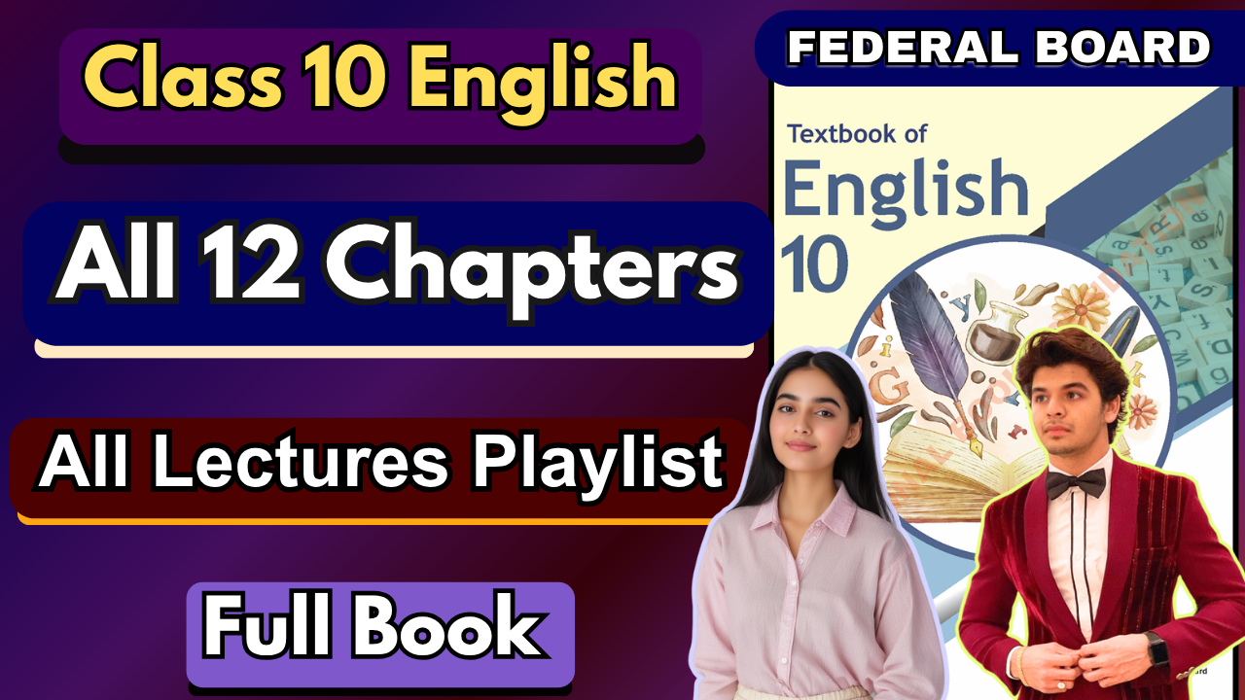

**Glossary:**

**Given below are the difficult words from the unit. Look at their meanings and use these words in your own sentences.**

| **Words** | **Meaning** |
| --- | --- |
| gentlest | characterized by a mild and kind nature |
| impatient | not tolerant of delay or opposition |
| admonition | gentle reproof or warning |
| feeblest | lacking physical strength especially as a result of age or illness. |
| waywardest | most difficult to control or manage due to wayward behaviour |
| aiseles | passages between rows of seats in a building, such as a church or theater |
| incites | provokes or stirs up a reaction or emotion |
| timid | shy or lacking in self-confidence |
| minutest | extremely small or insignificant |
| rampant | unrestrained or unchecked |
| impetuous | acting or done quickly without thought or care |
| assembly | a gathering of people for a particular reason |
| suffice | be enough or adequate |
| lamps | in the context of the poem, likely refers to celestial bodies or sources of light |
| infinite | endless or limitless |
| affection | deep love and care |
| infiniter | more infinite; suggesting an even greater degree of infiniteness |
| bending | in the context of the poem, likely refers to celestial movement or gesture |
| sky | the expanse of air over the earth |
| silence | absence of sound; stillness |



The following are the sentences for the above mentioned words:

1. **Gentlest** – She spoke in the **gentlest** tone to calm the crying child.
2. **Impatient** – He grew **impatient** while waiting in the long queue.
3. **Admonition** – The teacher’s **admonition** reminded the students to stay focused.
4. **Feeblest** – Even the **feeblest** voice deserves to be heard.
5. **Waywardest** – The mother cared for her child, even in his **waywardest** moods.
6. **Aisles** – The bride walked down the church **aisles** with a smile.
7. **Incites** – His speech **incites** people to work for peace.
8. **Timid** – The **timid** kitten hid under the table during the storm.
9. **Minutest** – She noticed the **minutest** detail in the painting.
10. **Rampant** – Weeds grew **rampant** in the abandoned garden.
11. **Impetuous** – His **impetuous** decision got him into trouble.
12. **Assembly** – The school held a morning **assembly** in the courtyard.
13. **Suffice** – One glass of water will **suffice** for the short walk.
14. **Lamps** – The street **lamps** lit up as night fell.
15. **Infinite** – The sky seemed to stretch into **infinite** space.
16. **Affection** – She showed deep **affection** for her younger brother.
17. **Infiniter** – Nature’s **infiniter** care surrounds all creatures, big or small.
18. **Bending** – He came **bending** under the heavy weight of the sack.
19. **Sky** – Birds soared high in the clear blue **sky**.
20. **Silence** – The **silence** in the library was calming.

**Reading and Critical Thinking Skills**

**A. Reading Comprehension Questions:**

**i. What is the central theme or message conveyed by Emily Dickinson in "Mother Nature"?   
Ans.** The poem presents Nature as a gentle, nurturing mother who lovingly cares for all her children—whether strong, weak, or wayward. Emily Dickinson emphasizes Nature’s patience, affection, and balanced authority. The message is that Nature embodies both tenderness and discipline, guiding life with care and order.

**ii. How does the poet depict Nature's actions during the time when “all the children sleep”?   
Ans.** When the world rests, Nature turns away briefly to “light her lamps” (the stars and moon). She then bends from the sky with “infinite affection” and ensures calmness by imposing silence everywhere. This conveys her role as a watchful guardian who tends to the earth even in quiet hours.

**iii. Explore the metaphorical meaning behind the line, "Her golden finger on her lip, / Wills silence everywhere." What does it suggest about Nature's role?**

**Ans.** This image portrays Nature as a mother signaling her children to remain quiet. Metaphorically, it suggests Nature’s ability to enforce peace and order. Her “golden finger” represents both authority and gentleness—she doesn’t silence through harshness, but through a quiet command that is universally obeyed.

**iv. Reflect on the use of nature elements (squirrel, bird, cricket, flower) in the poem. How do they contribute to the overall message?**

**Ans.**

* **Squirrel and bird** – Represent energetic, impulsive beings needing restraint, showing Nature’s role as a gentle disciplinarian.
* **Cricket and flower** – Symbolize the timid and humble creatures, whose smallest voices and prayers are still cherished.

Together, they reflect Nature’s inclusivity—she nurtures and values every creature, from the restless to the meek, thus reinforcing the theme of universal motherhood.

**v. How does Emily Dickinson portray the duality of Nature's character - gentle mother and enforcer of silence?**

**Ans.**

* **Gentle Mother** – Patient, affectionate, guiding even the weakest with mild admonition.
* **Enforcer of Silence** – Commanding peace and stillness with quiet authority when needed.  
   This duality highlights the balance in Nature’s character: tender yet firm, nurturing yet powerful enough to maintain harmony.

**Extended Reading**

**Read the given paragraph and examine different points of view (e.g., first-person, third-person narrative). Determine an author’s point of view or purpose in a text. Analyse how the author distinguishes his or her position from that of others.**

**Ans.**

The passage presents two distinct points of view:

1. **First-person point of view (the young man’s perspective):** The narrator begins by describing his own hunger, struggle, and inner conflict. Through “I” statements, we see his personal feelings—sympathy, guilt, and eventual satisfaction after helping the woman. This perspective emphasizes the internal battle between self-interest and compassion.

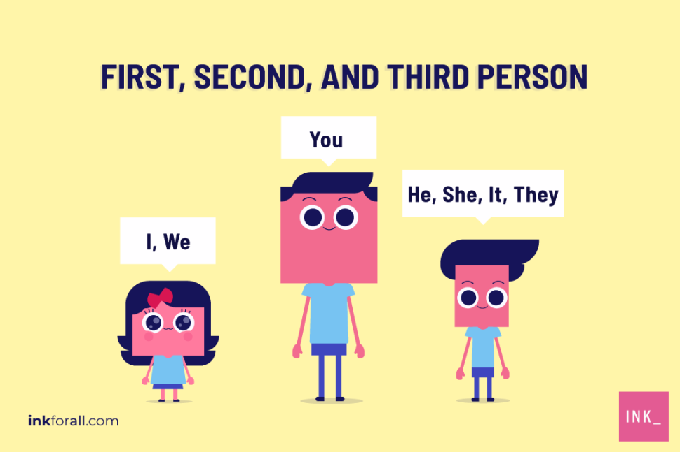

1. **Third-person point of view (Sarah, the waitress):** The focus shifts to Sarah, who observes the scene from outside. Her narration is in third person, showing an external perspective. Unlike the young man, Sarah is not directly involved, but she interprets his act as a rare moment of kindness in a world often marked by indifference.

**Author’s purpose:** The purpose of the text is to highlight the transformative power of kindness. By using both first-person and third-person narration, the author shows how a single act of compassion not only impacts the giver and the receiver but also inspires observers.

**How the author distinguishes positions:**

* The young man’s perspective reveals the *personal struggle and moral choice*.
* Sarah’s perspective provides an *objective reflection on the broader meaning of the act*.

**B. Antonym, Denotation, and Connotation:**

**i. Provide the antonym for each of the following words:**

**Ans.**

* **Gentlest** → Harshest / Cruelest
* **Impatient** → Patient
* **Timid** → Bold / Confident
* **Rampant** → Restrained / Controlled
* **Infinite** → Finite / Limited

**ii. Provide the denotation (literal meaning) for the words below:**

**Ans.**

* **Aisles** → Passageways between rows (in a forest, hills, or any structured area)
* **Assembly** → A group of beings gathered together
* **Lamps** → Sources of light (here, the stars and moon)
* **Sky** → The expanse of air above the earth
* **Silence** → Absence of sound; stillness

**iii. Explore the connotations (emotional or associative meanings) of the following words in the context of the poem:**

**Ans.**

* **Feeblest** → Symbolizes weakness or fragility, yet still under Nature’s gentle care
* **Impetuous** → Suggests restless or uncontrolled energy, needing Nature’s restraint
* **Affection** → Reflects Nature’s loving, maternal qualities toward all creatures
* **Minutest** → Conveys smallness or insignificance, yet still valued by Nature
* **Bending** → Suggests a protective, nurturing gesture, as though Nature leans close with care

**iv. Choose the antonym for each word:**

**Ans.**

* Ascend → **Descend**
* Expand → **Contract**
* Conquer → **Surrender**
* Modern → **Primitive**
* Intense → **Mild**

**v. Choose the correct word according to the context of the sentence:**

**Ans.**

**a)** The sunsets, painting the sky in vivid colours, are an **extraordinary** sight. (Common/Extraordinary)

**b)** His patience seemed to **decrease** as the wait became longer. (Decrease/Increase)

**c)** The river flowed gently, its current **calm** and serene. (Turbulent/Calm)

**d)** In the desert, the temperatures during the day can be **extreme**, reaching over 100 degrees. (Mild/Extreme)

**e)** The politician's speech was filled with **empty** promises, but few were fulfilled. (Genuine/Empty)

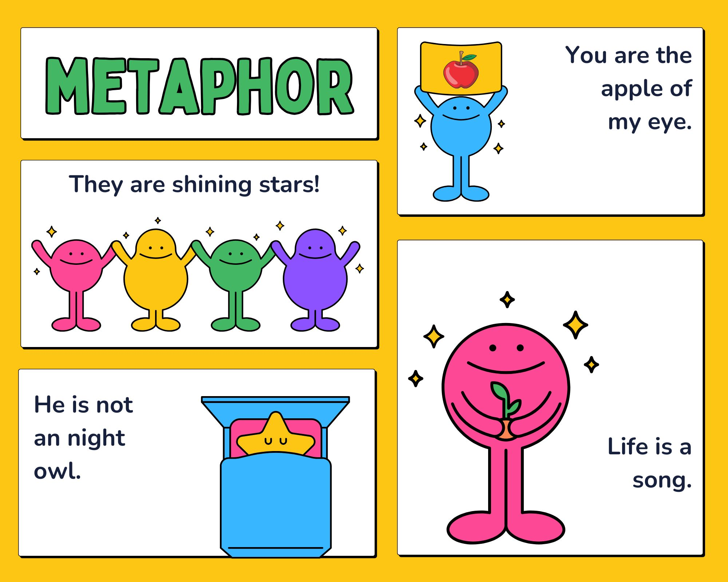

**C. Metaphors**

A **metaphor** is a figure of speech in which one thing is described in terms of another, even though they are not literally the same. Unlike a simile, which uses words such as *like* or *as* (e.g., “life is like a journey”), a metaphor makes a direct comparison (e.g., “life is a journey”).

Metaphors help to:

* **Create vivid imagery:** They make abstract or complex ideas easier to understand by linking them to familiar objects or experiences.
* **Add emotional depth:** They carry connotations that evoke feelings and associations.
* **Enrich expression:** They make language more poetic, imaginative, and impactful.

**Examples:**

* “Time is a thief” → suggests that time takes away moments of life.
* “Her voice was music to his ears” → conveys beauty and pleasure in her voice.
* “The world is a stage” (Shakespeare) → life is compared to a performance where people play roles.

In Emily Dickinson’s poetry, metaphors often connect human emotions with nature, showing deep relationships between the natural world and human life.

**i. Complete the metaphor:**

a) Time is a **river**.  
b) Laughter is the best **medicine**.  
c) The classroom was a **hive** of buzzing bees.  
d) His words were an **anchor** in the storm of confusion.

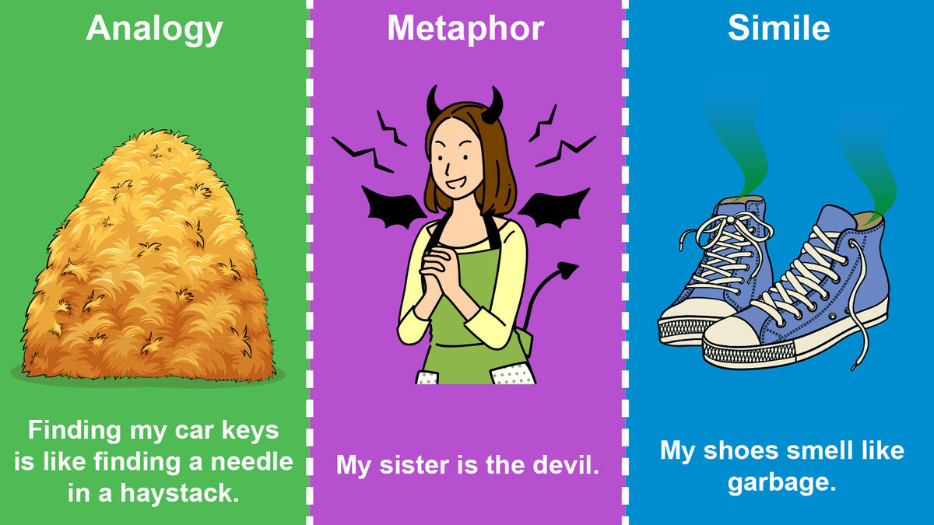

**ii. Create a metaphor:**

a) Compare the feeling of disappointment to a **deflated balloon**.  
b) Describe a successful team as a **well-oiled machine**.  
c) Portray the night sky as a **blanket of diamonds**.  
d) Express the idea of courage using the metaphor of a **burning flame**.

**iii. Identify the metaphor in the sentence:**

a) The news spread like wildfire through the small town. (News/Wildfire)  
→ **Wildfire** is the metaphor for how quickly the news spread.

b) Her voice was music to his ears. (Music/Voice)  
→ **Music** is the metaphor for the beauty of her voice.

c) The city never sleeps. (City/Sleeps)  
→ **Sleeps** is the metaphor showing the city is always active.

d) Time is a thief stealing moments from our lives. (Time/Thief)  
→ **Thief** is the metaphor for how time takes life’s moments away.

**D. Personification**

**i. Identify the personification:**

a) The stars **danced** in the midnight sky. (Stars are personified as dancers.)  
b) The wind **whispered secrets** through the trees. (Wind is personified as whispering.)  
c) The sun **smiled** down on the beach. (Sun is personified as smiling.)  
d) Time **marches** on, never looking back. (Time is personified as marching like a soldier.)

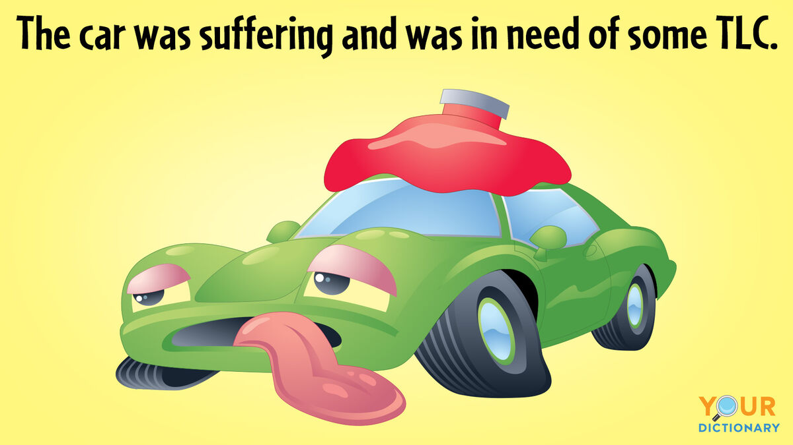

**ii. Create personification:**

a) The rain tapped gently on the window, begging to be let inside.  
b) The mountain stood tall and proud, watching over the valley like a guardian.  
c) The moon asked the stars to keep her company in the lonely night sky.  
d) The river sighed with relief as it reached the open sea after a long journey.

**iii. Identify the personification in the sentence:**

a) The old house **groaned** as if it were in pain. (House is personified.)  
b) The flower **nodded** in agreement with the gentle breeze. (Flower is personified.)  
c) Fear **knocked** on the door, but courage **answered**. (Fear and courage are personified.)  
d) The camera **captured the joy** of the moment. (Camera is personified as capturing emotions.)

**E. Alliteration**

**Alliteration** is a literary device where words that are close together begin with the same consonant sound. It is often used in poetry and prose to create rhythm, musicality, and emphasis in language.

Unlike rhyming, which occurs at the end of words, alliteration focuses on the repetition of initial sounds. For example:

* *“Sally sells seashells by the seashore.”* (repetition of the **s** sound)
* *“The wild wind whispered.”* (repetition of the **w** sound)

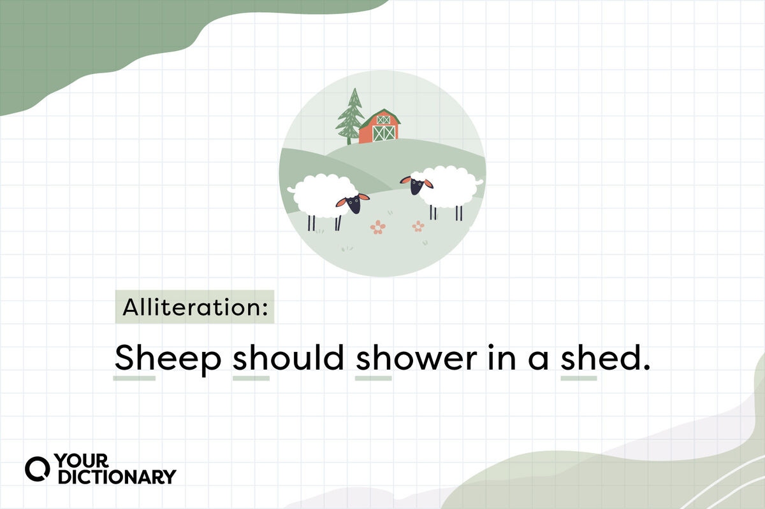

**Functions of Alliteration:**

1. **Creates rhythm and flow** – making lines more memorable.
2. **Draws attention** – emphasizing particular words or themes.
3. **Adds mood or tone** – soft sounds (like *s*) create calmness, while harsh sounds (like *k* or *t*) add intensity.
4. **Enhances imagery** – makes descriptions more vivid and engaging.

**i. Fill in the Blanks:  
Ans.**  
i) The **elegant** eagle soared through the sky.  
ii) The **wild** waves crashed against the shore.  
iii) The **thoughtful** teacher patiently explained the lesson.

**ii. Identify and underline the alliterative words in the following sentences:  
Ans.**

* "Five **feisty felines frolicked** in the garden.”
* "The **busy bees buzzed** around the **blooming** flowers."

**Vocabulary and Grammar**

**A. Transitive and Intransitive Verbs**

A **verb** is a word that shows an action or state of being. Verbs can be classified into two main types: **transitive** and **intransitive**, depending on whether they need an object to complete their meaning.

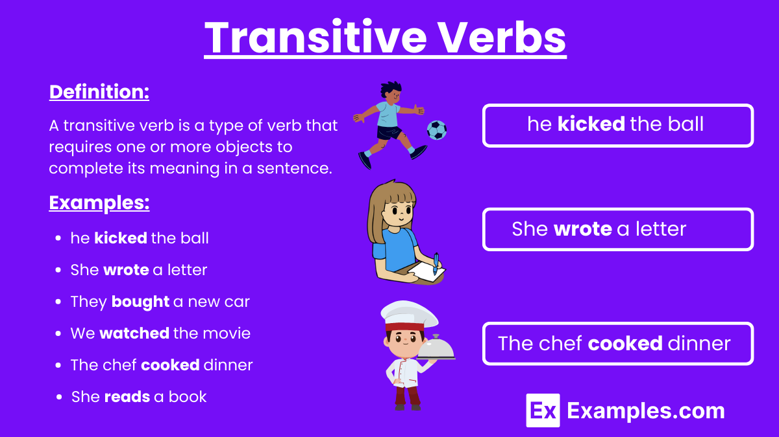

### **1. Transitive Verbs**

A **transitive verb** requires an object (a noun or pronoun that receives the action) to complete its sense. Without an object, the sentence feels incomplete.

* **Examples:**
  + She **reads** a book. (object = book)
  + The boy **kicked** the ball. (object = ball)
  + They **built** a sandcastle. (object = sandcastle)

### **2. Intransitive Verbs**

An **intransitive verb** does not require an object to complete its meaning. The action ends with the subject itself or is complete without an object.

* **Examples:**
  + The baby **cried**. (no object)
  + The sun **shines** brightly.
  + The children **slept** peacefully.

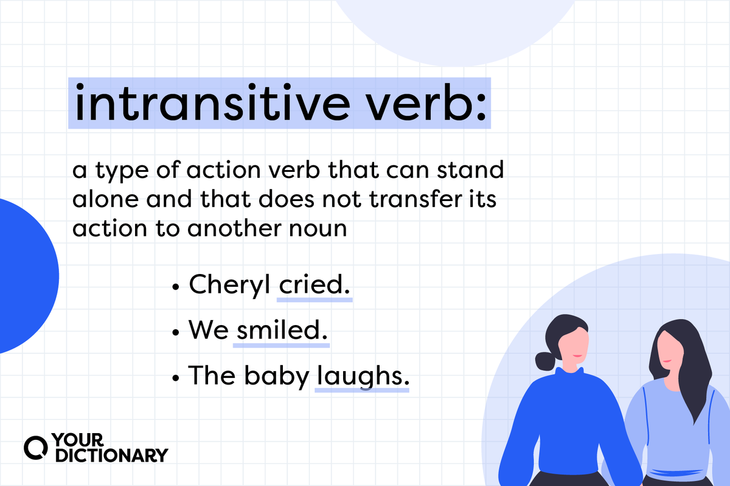

### **Key Difference**

* **Transitive verbs** → Need an object. (e.g., “She plays the guitar.”)
* **Intransitive verbs** → Do not need an object. (e.g., “She sleeps.”)

**i. Identify the verb type (Transitive / Intransitive):  
Ans.** a) She ate the delicious cake. → **Transitive** (object = cake)  
 b) The cat jumped onto the window sill. → **Intransitive** c) He built a sandcastle on the beach. → **Transitive** (object = sandcastle)  
 d) The river flowed swiftly. → **Intransitive** e) The music played softly in the background. → **Intransitive** f) Sara bought a new dress for the party. → **Transitive** (object = dress)

**ii. Determine the object in the sentences:  
Ans.** a) She reads a **book**.  
 b) The wind blew the **leaves**.  
 c) He wrote a **letter**.  
 d) They painted the **fence** blue.

**iii. Create sentences with both types:  
Ans.** a) Transitive: She **kicked the ball** across the field.  
 b) Intransitive: The baby **cried** loudly.  
 c) Interrogative (Transitive): Did he **finish the project**?  
 d) Interrogative (Intransitive): Did they **arrive** on time?

**iv. Fill in the blanks with the appropriate preposition:  
Ans.**

a) She walked **through** the park to meet her friends.  
b) The cat jumped **onto** the table.  
c) The airplane flew **above** the clouds.  
d) They sailed **around** the island.  
e) The hiker climbed **up** the mountain.  
f) The train travels **through** the tunnel.  
g) The ball rolled **down** the street.  
h) He swam **across** the river to reach the other side.  
i) The kids ran **towards** the school bus.  
j) She placed the keys **on** the table.  
k) We walked **through** the forest and discovered a hidden lake.  
l) The river flows **through** the mountains.

**B. Active and Passive Voice**

**Voice** in grammar shows whether the subject of a sentence performs or receives the action of the verb. There are two main types: **active voice** and **passive voice**.

### **1. Active Voice**

In **active voice**, the subject performs the action of the verb. This form is direct, clear, and commonly used.

**Structure:  
Subject + Verb + Object**

**Examples:**

* The chef **prepares** a delicious meal.
* The teacher **explained** the lesson.
* She **will complete** the assignment.

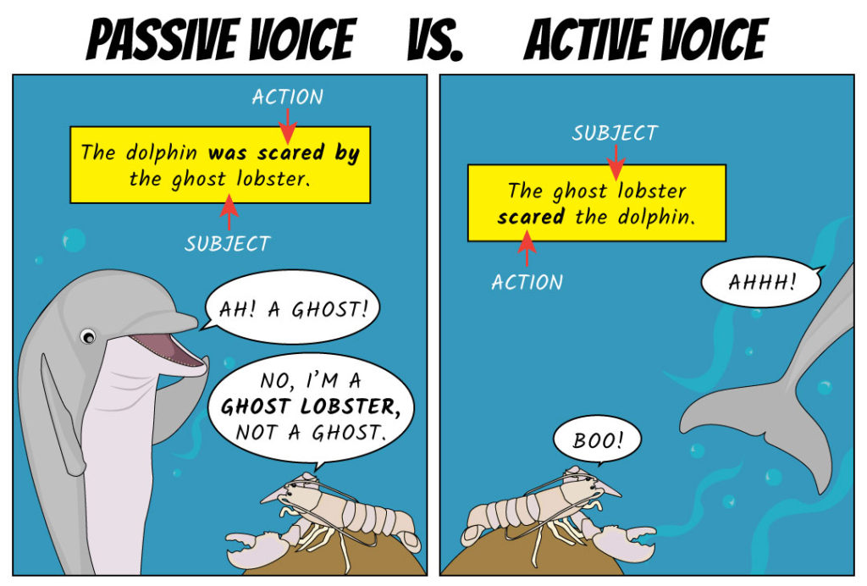

### **2. Passive Voice**

In **passive voice**, the subject receives the action of the verb. The doer of the action may or may not be mentioned. This form is used when the focus is on the action or the object rather than the doer.

**Structure:** **Object (receiver) + Auxiliary verb (be) + Past participle verb + (by + Subject)**

**Examples:**

* A delicious meal **is prepared** by the chef.
* The lesson **was explained** by the teacher.
* The assignment **will be completed** by her.

**1. Change Active voice to Passive voice:  
Ans.** i. The chef prepares a delicious meal.   
→ A delicious meal **is prepared by the chef**.

ii. She will complete the assignment.   
→ The assignment **will be completed by her**.

iii. Someone is painting the fence.   
→ The fence **is being painted by someone**.

iv. They have cancelled the event.   
→ The event **has been cancelled by them**.

v. The students completed the project.   
→ The project **was completed by the students**.

vi. The chef prepared a delicious meal.   
→ A delicious meal **was prepared by the chef**.

vii. The gardener trims the bushes every week.   
→ The bushes **are trimmed by the gardener every week**.

**2. Change Passive voice to Active voice:  
Ans.** i. The cake was baked by Mary.   
→ Mary **baked the cake**.

ii. A new song is being sung by the choir.   
→ The choir **is singing a new song**.

iii. The report has been written by the manager.   
→ The manager **has written the report**.

iv. The door was opened by John.   
→ John **opened the door**.

**3. Identify whether Active (A) or Passive (P):  
Ans.** i. The teacher explained the lesson.   
→ **A**

ii. A beautiful song was sung by the choir.   
→ **P**

iii. They built a sandcastle on the beach.   
→ **A**

iv. The mysterious novel was written by the author.   
→ **P**

v. Someone is painting the fence.   
→ **A**

vi. They have cancelled the event.   
→ **A**

vii. The letter has been written by Sarah.   
→ **P**



